Fall 2022 Move In Schedule
Thursday, August 18th | 8:00am to 5:30pm
Friday, August 19th | 10:00am to 5:30pm (OC Campus will be closed from 8am to 10am)
Saturday, August 20th | 8:00am to 5:30pm
Sunday, August 21st | 8:00am to 5:30pm

Students will report to the Saulsbury Campus Center -201 W. University Blvd. Odessa, Texas 79764. Outside of normal business hours, residents should report to Century Commons (CC) - 2311 Andrews Highway, Odessa, Texas 79761.

Step 1: Student Life Table (SCC Zant Room upstairs)
Residents will check in at the Student Life (SL) table in the Saulsbury Campus Center lobby (SCC) to check the following information:
- Housing application on file
- $50.00 application fee
- $200 deposit
- Bacterial Meningitis Vaccine
- Payment plan enrollment or no room and board balance
- Ask student if they chose to pay dorm deposit with education stimulus grant
- Make sure SL representative initials your Check- In form

At this station residents will also receive the Residence Life folder with Check-In Requirements paperwork that must be turned in at the SCC to the SL representative:
- Confidential Contact Information (CCI) form
- Student Housing Agreement (SHA)
- Make sure SL representative initials your Check- In form

Step 2: Advising Table (Zant Room upstairs)
At this station, the residents will check their class schedule with the Athletic Advisor and make any necessary changes to their schedule.
- Make sure class schedule is correct
- Make changes
- Get a copy of class schedule
- Make sure your advisor initials your Check- In form

Step 3: OC Wrangler ID (Zant Room upstairs)
At this station, residents will take their photo for their ID and download the ID app on their phone.
- Take picture
- Download app
- Make sure ID is working
- Make sure a Wrangler Express Center representative initials your Check- In form

Once the resident has completed all of the steps above and has initials by each box on the Move- In Check List, residents can proceed to Century Commons (CC) - 2311 Andrews Highway, Odessa, Texas 79761.

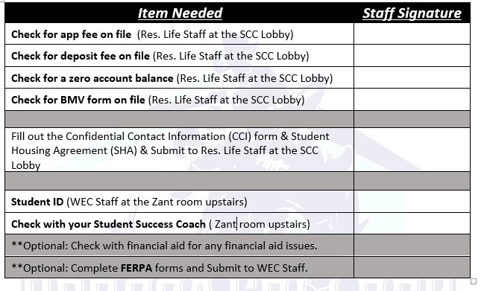

Step 4: Century Commons (CC) Check In
- Station 1 - Outside CC:
  - Reminder: residents are only allowed two guest during move in
    - Failure to comply can result in a warning and or violation charge to student account
  - Receive arm band to enter and exit CC and or Wrangler Hall (WH)
    - This armband must remain on throughout check-in until Monday, August 22nd
  - Receive their room # and keycard for suite door only
    - Bedroom doors will be open
  - Explain the Unit Condition Report inside their folder
      - Record any damages
      - Be detailed on the UCR
      - Students will be charged for unreported damages (i.e. torn blinds, chipped paint, floor stains, dented or stained furniture, etc.)
      - Remind students to return UCR to Station #2.
    - REMINDER the residents CANNOT change rooms or bedrooms unless given permission by the Residence Life Director
- Station 2- Outside CC
  - Return the UCR
    - Make sure the UCR has the following:
      - Student signature
      - Key codes
      - Student ID
      - Student Name
      - Student Room #
      - And all fields have been completed
  - Residents will receive their bedroom key and mail key envelope
- Enjoy your stay with Odessa College Residence Life!

